Model Development

Model:

A model can be thought as a mathematical equation used to predict a value given one or more other values

Relating one or more independent variables to dependent variables

If the data is relevant the model will be as accurate.

Linear Regression and Multiple Linear Regression

Simple Linear regression refer to one independent variable to make prediction.

Multiple Linear regression refer to multiple independent variables to make prediction.

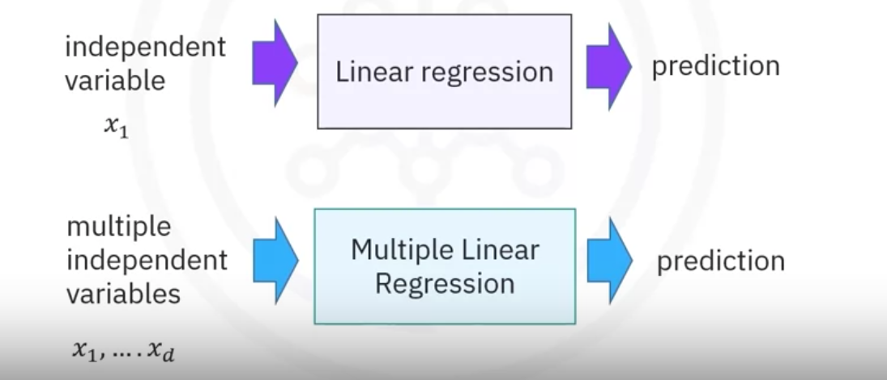

Simple linear regression helps us to understand the relationship between 2 variables.

1. The predictor(independent) variable – x
2. The target(dependent) variable – y

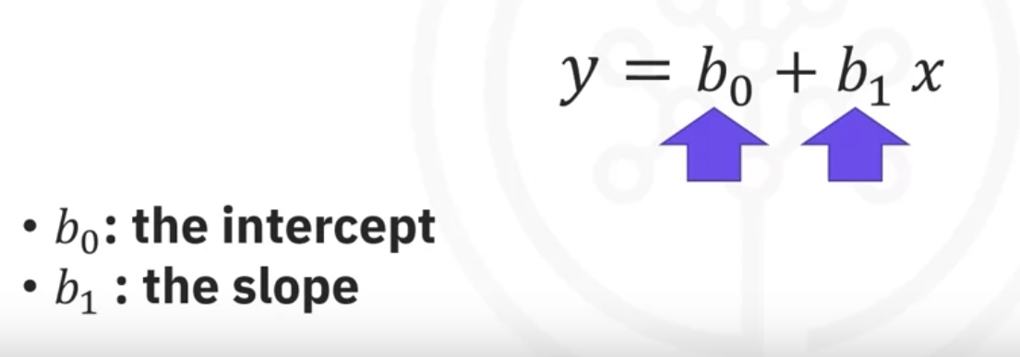

When we fit the model we come up with these parameters.

Using the formula above, if we know the slope and intercept, we can find the yhat.

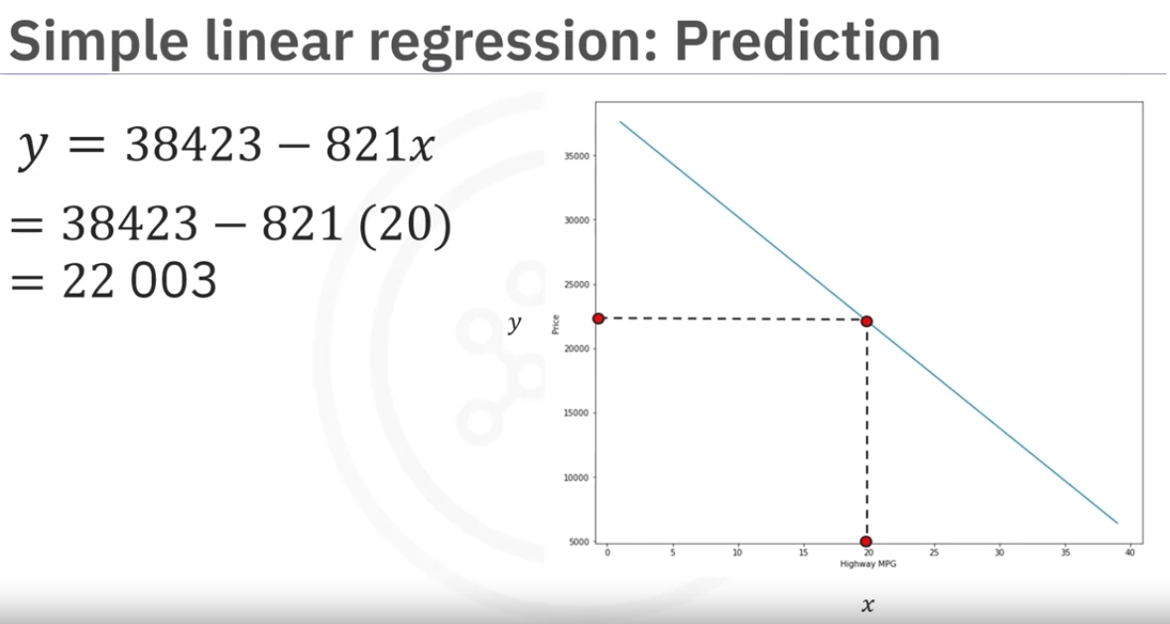

as we can see from the image, if we know the slope and intercept, we can provide the x valueand we can find the price.

Continued in next page.

Fitting a model:

We can take existing data points (training data) and fit the model. In this case it will find out the slope and intercept.

WE usually store data in 2 dataframes or numpy arrays.

X(independent) and Y(dependent)

Depending on differnt scenarious, people pay different price for the car.

These factors will move the price a little bit up or down than the original price of the car. For example, the car was vintage or a special edition car.

Assuming this a small random value will be added or subtracted to each the price. This is called noise.

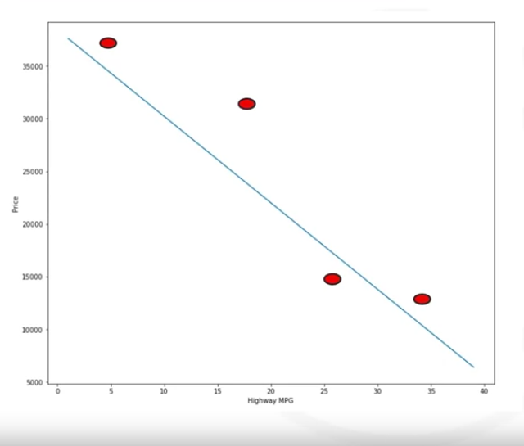

As we can see from the image the random noise is added to the data.

Now we use this data to fit the model and we get the parameters (b0, b1).

Now we have a model and we call it yhat

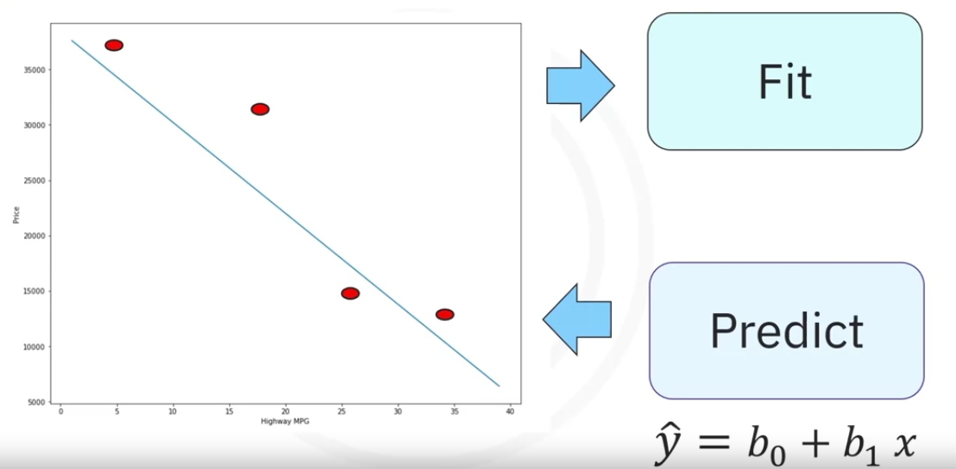

we can now predict the price of a car. But remember our model is not perfect. We will sometimes get wrong price .

we can find this by comparing the predicted price vs actual price,

This could be because of the noise or for some other reason.

Fitting a simple linear model estimator

*from sklearn.linear_model import LinearRegression # importing the model*

*lm = LinearRegression() # creating model object.*

*# grabbing independent variables(X) and dependent variable(Y)*

*X = df[[‘highway-mpg’]]*

*Y = df[‘price’]*

*# fitting the model*

*lm.fit(X, Y)*

*# Prediction*

*Yhat = lm,predict(X)*

*# the output of the predict will be an array which will have the same number of values as the input for the predict.*

Accessing the slope and intercept

we can use the lm.intercept_ and lm.coef_ to get the details.

we can put these values in the formula.

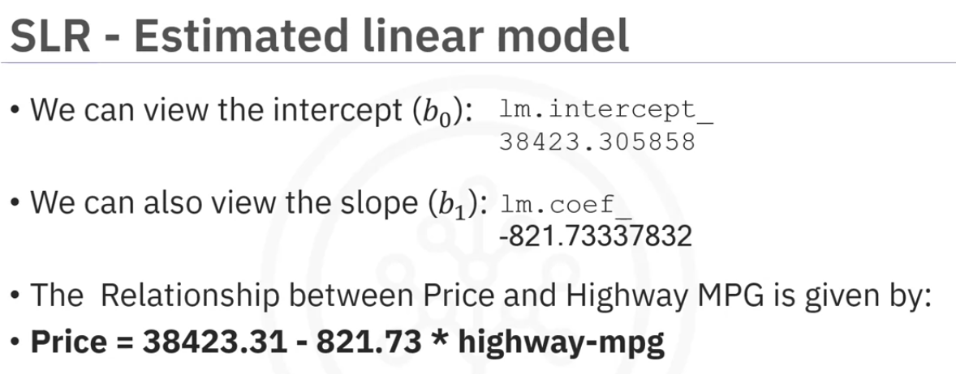

Multiple Linear Regression

There will be two or more x variables and one y variable.

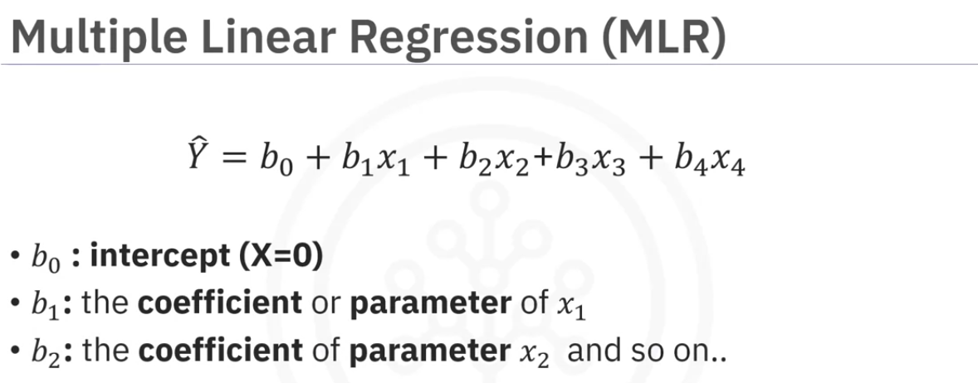

as we can see from the image we can use multiple x values which gives us multiple coefficients.

Note: the number of coefficients/slopes will be equal to number of independent variables.

Fitting a multiple linear model estimator

*from sklearn.linear_model import LinearRegression # importing the model*

*lm = LinearRegression() # creating model object.*

*# grabbing independent variables(X) and dependent variable(Y)*

*# x will be a dataframe here.*

*X = df[[‘horsepower’, ‘curb-weight’, ‘engine-size’, ‘highway-mpg’]]*

*Y = df[‘price’]*

*# fitting the model*

*lm.fit(X, Y)*

*# Prediction*

*Yhat = lm,predict(X)*

*# the output of the predict will be an ndarray which will have the same number of columns and rows as the input for the predict.*

*# yhat will have same number of rows.*

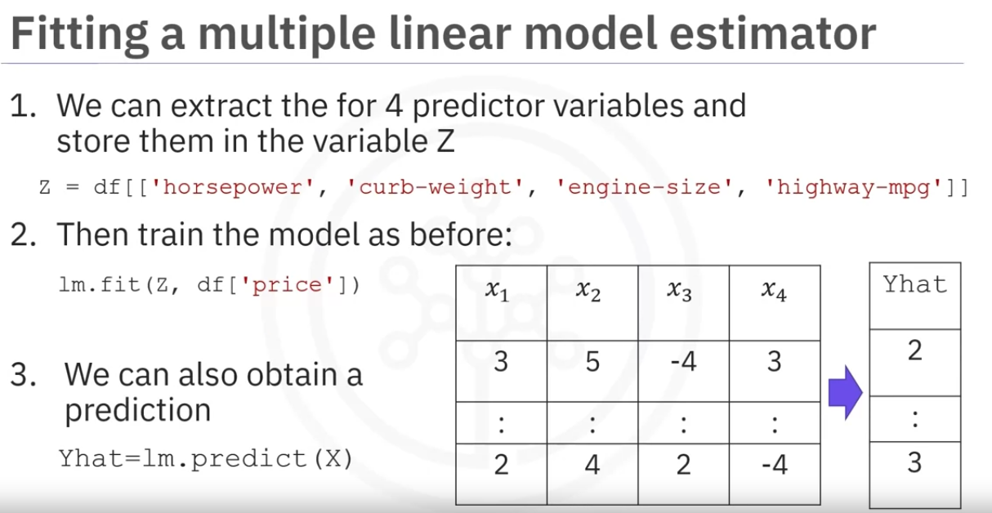

Now we can follow the same procedure of finiding the coefficients and y intercept and substitute in the formula.

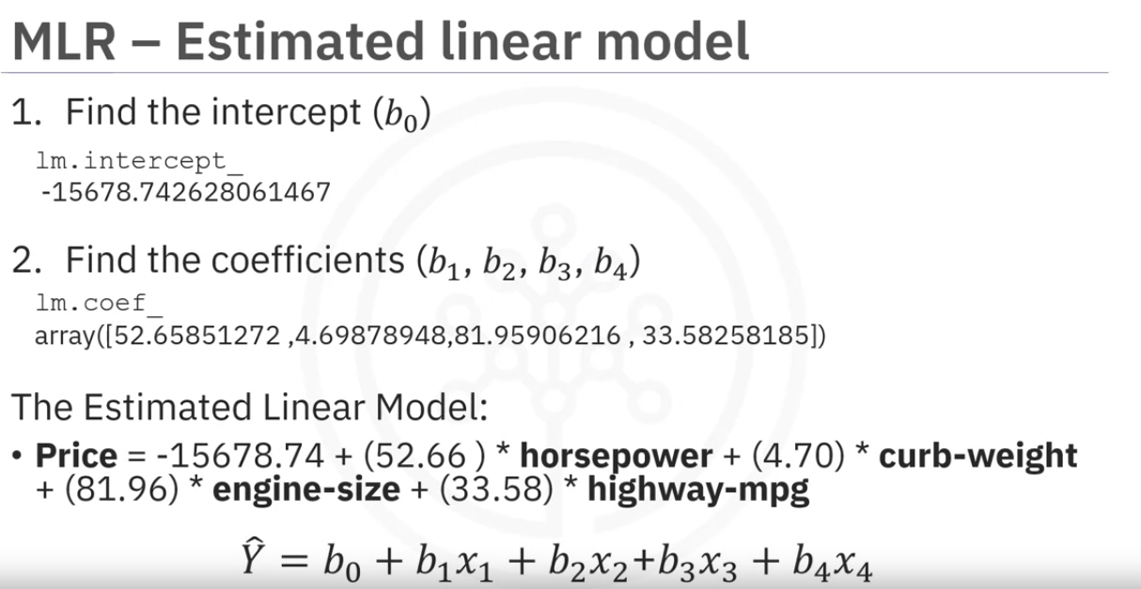

Model Evaluation Using Visualization

Regression Plot

Why use Regression plot?

It gives us a good estimate of:

* The relationship between two variables
* The strength of the correlation
* The direction of the relationship(positive or negative).

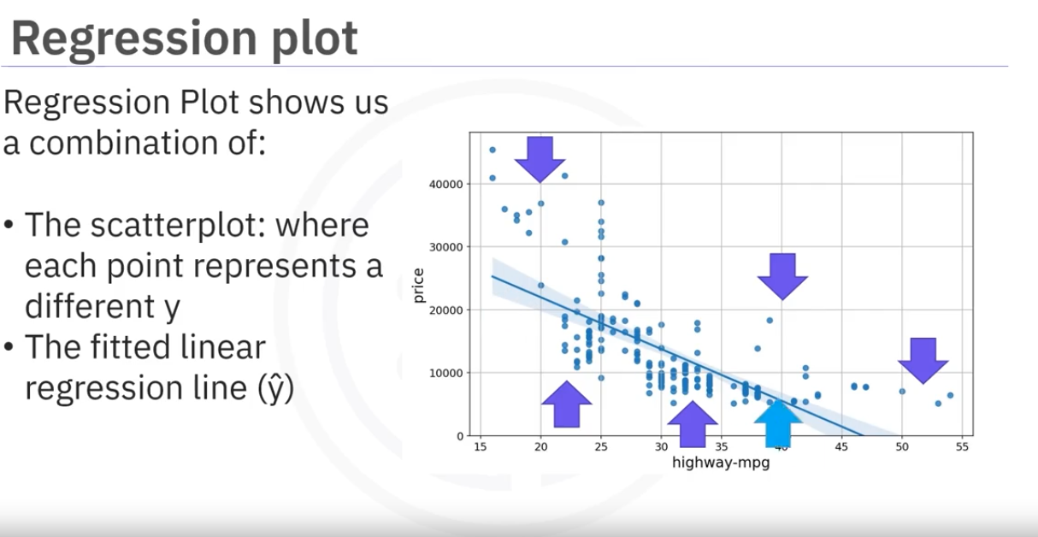

x- axis is independent variable and y axis is dependent variable

Each point represents a different target point,

The fitted line represents the predicted values.

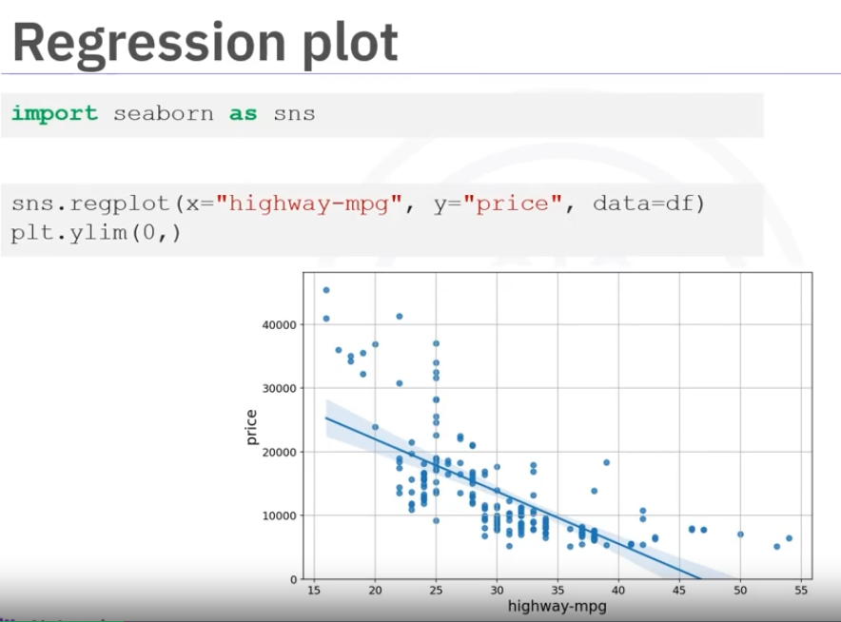

Residual Plot:

Residual plot represents the error between the actual value and the predicted value.

This is done by subtracting predicted value from actual value.

We then plot that value on to the y axis of the plot with the independent variable on the x axis.

Then we repeat this for all the points.

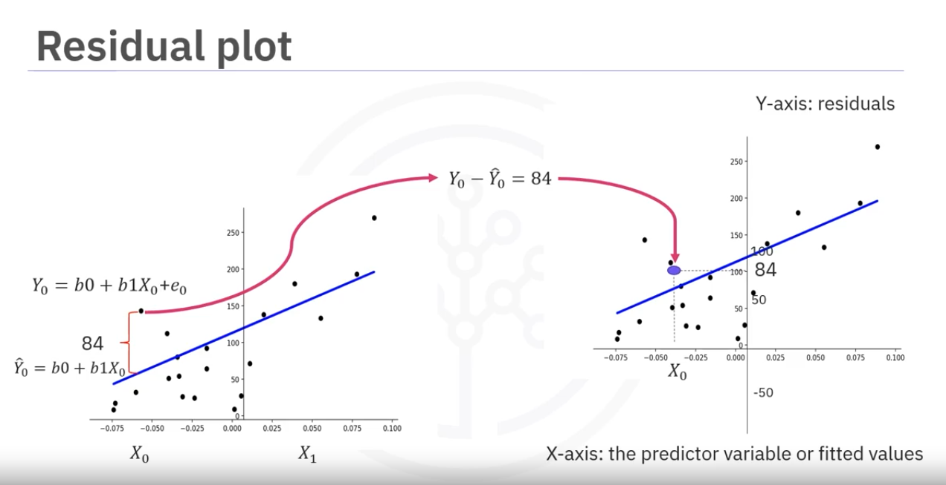

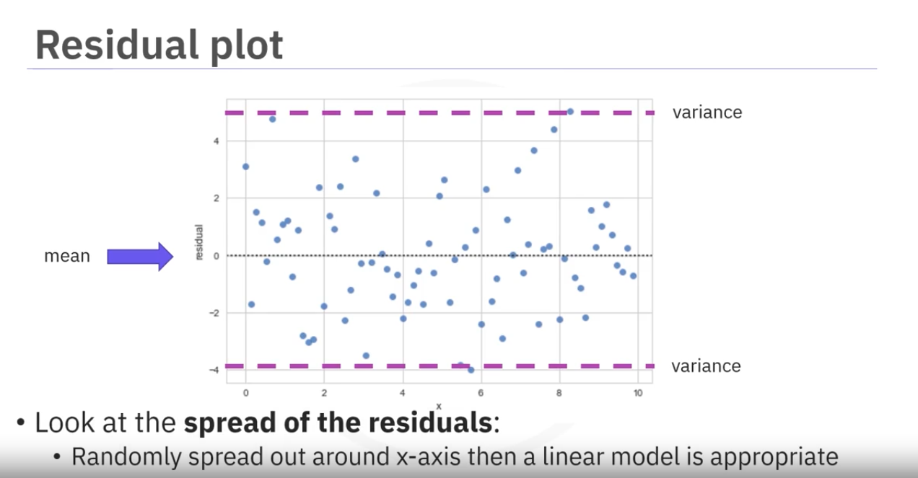

Looking at the graph above, we get some insights

We expect the graph to have 0 mean distributed along the x axis with similar variance. There is not curvature.

This type of plot suggests a linear regression is appropriate,

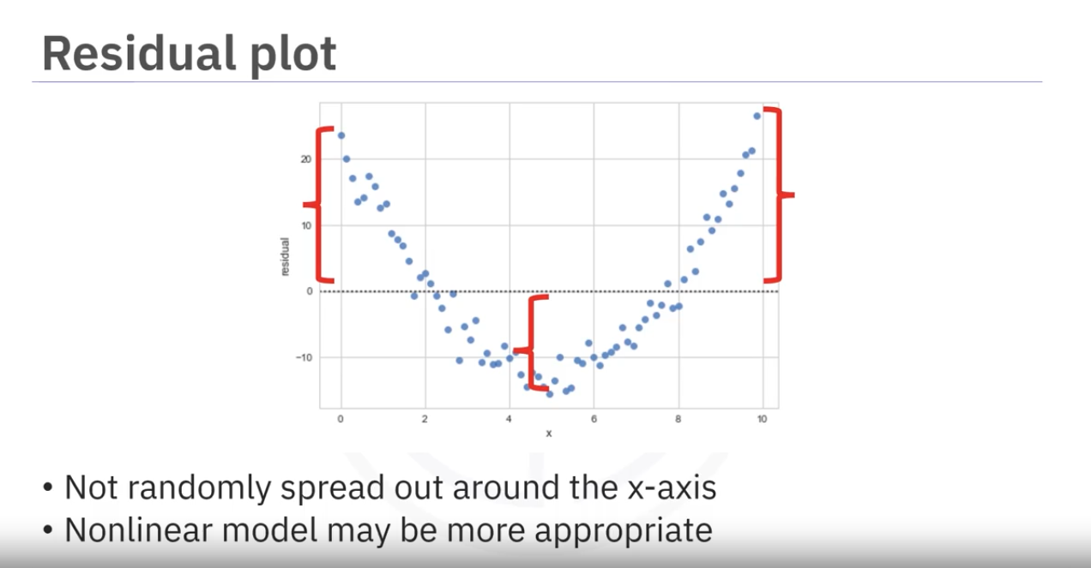

The above plot clearly shows a curve. It is not a good idea to use LinearRegression for this.

WE will deal with these later,

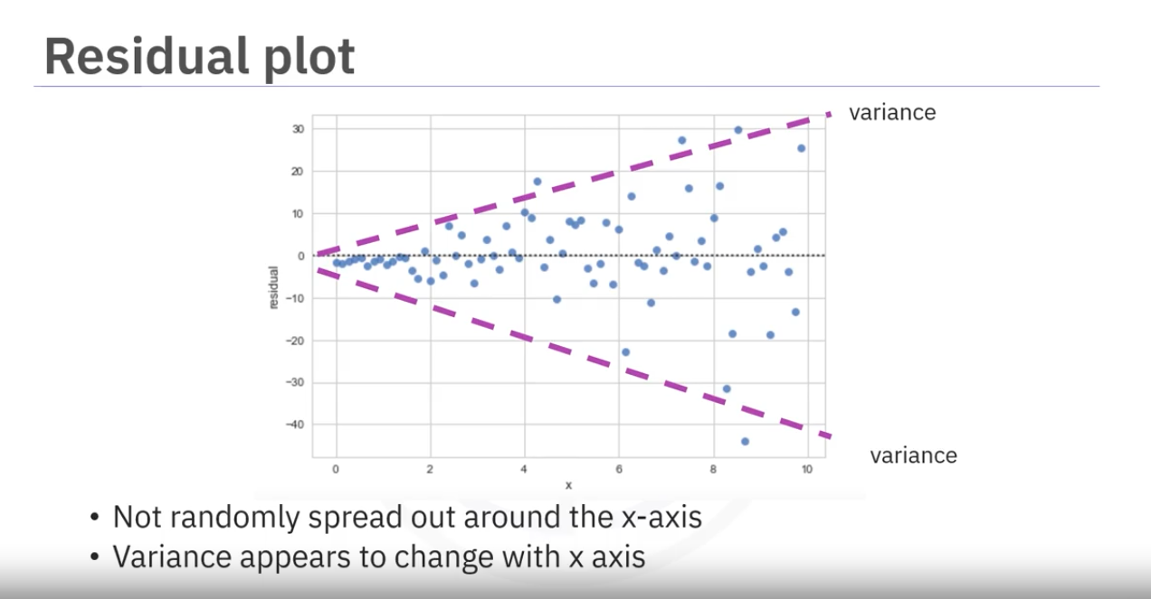

In this the variance seems to increase with x. Therefore our model is incorrect,

Creating Residual plot:

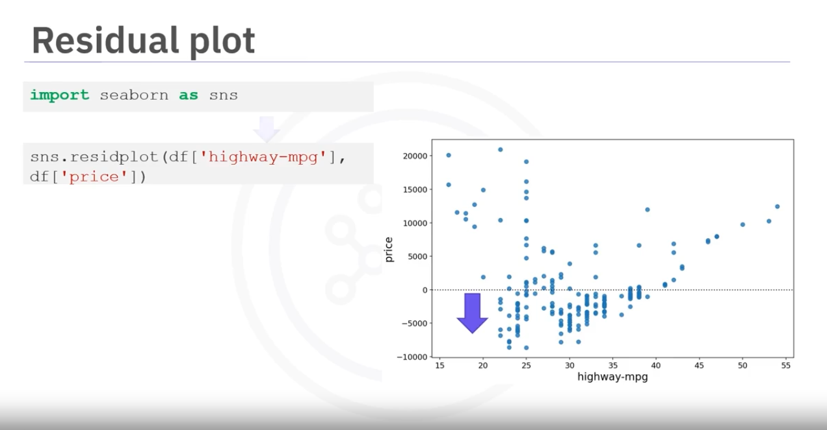

We can see there is a curvature to this graphs toward the bottom near 20 leading ti 55

Distrubution Plot:

This plot counts the predicted value vs actual value.

These are exremely useful for visualizing modelswith more than one independent variable or feature.

We count number of predicted points(which are in blue) which are approximatly equal to 1 then two and then 3.

Then we do the same with the actual values. which are in red

These are continuos value. So instead of drawing histograms, pandas will convert the graph into a distribution.

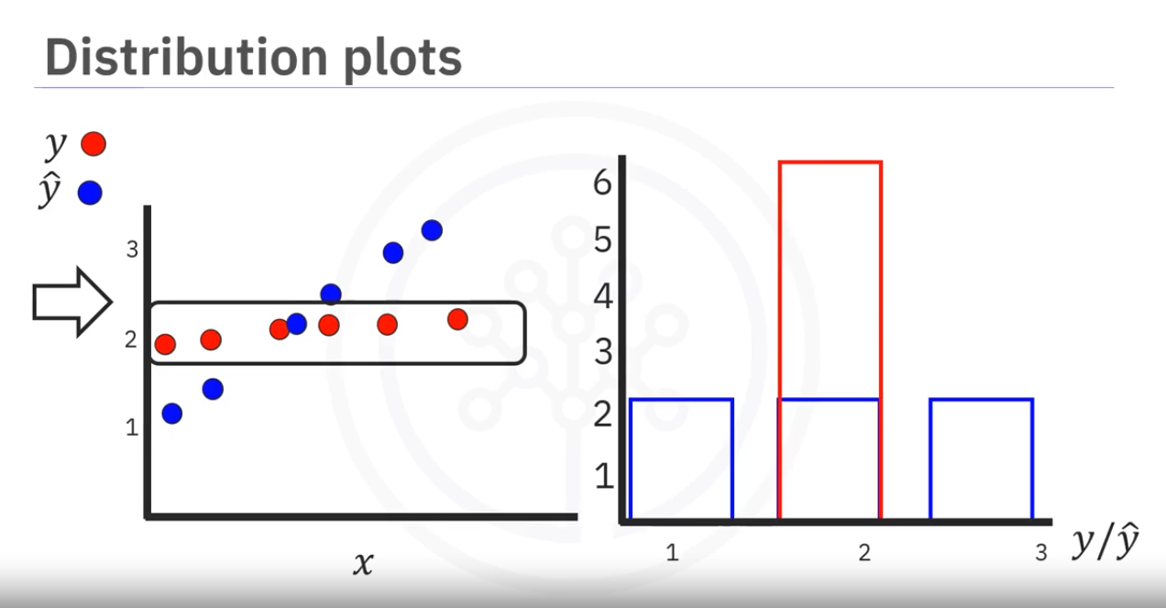

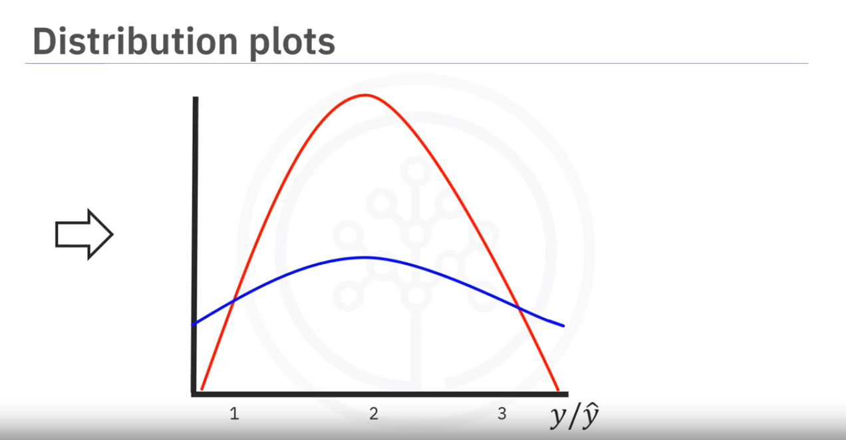

The vertical axis is scaled to make the area under the distribution equal to 1.

Example of a distribution plot:

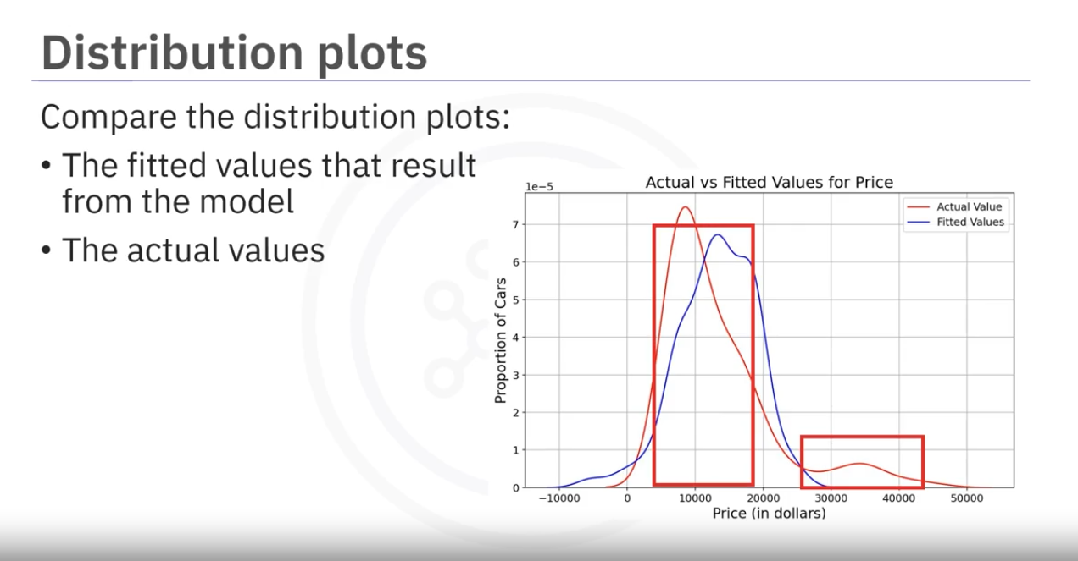

We can see that the predicted values in the range from 40000 to 50000 is inaccurate.

The prices in the region from 10k to 20k are much closer to the actual value.

Multiple Linear Regression: Distribution Plots:

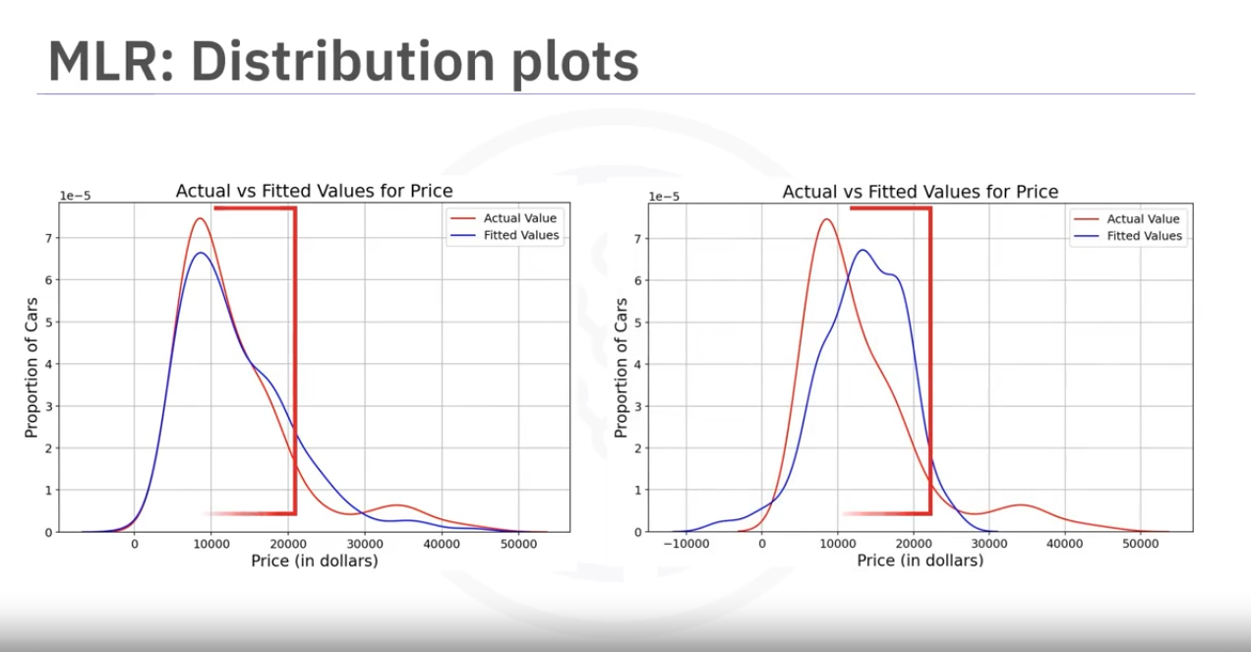

We see that the predicted vakues are much more closer to the actual values,

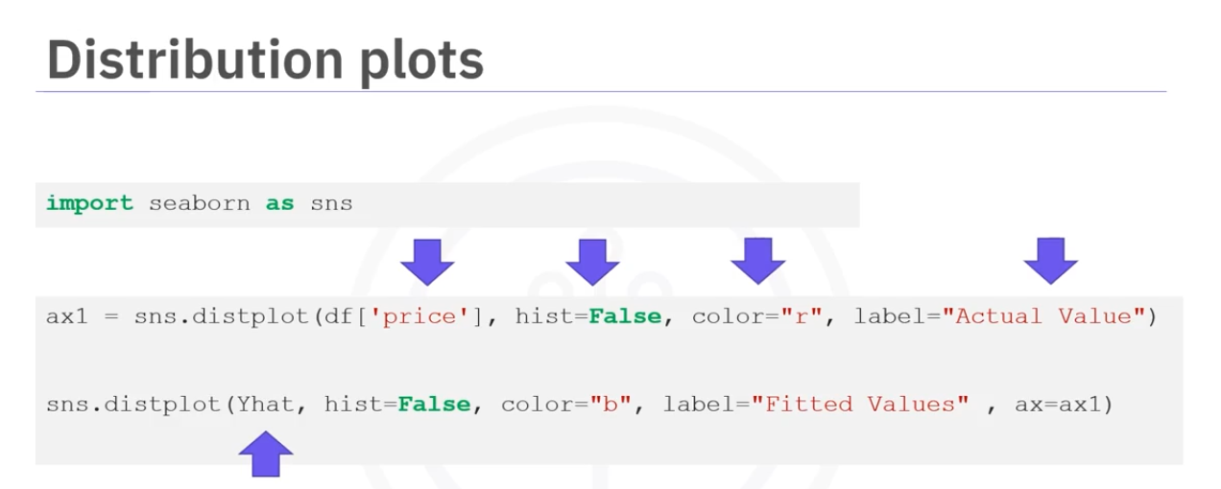

Polynomial Regression and Pipelines

When a linear model is not the best fit for our data? We choose polynomial regression.

We transform our data into a polynomial then use the inear regression to fit the parameters.

Polynomial regression is a special case of the general linear regression. useful for describing curiviinear relationships.

Curvilinear Relationships:

By squaring or setting higher-order terms of the predictor variables.

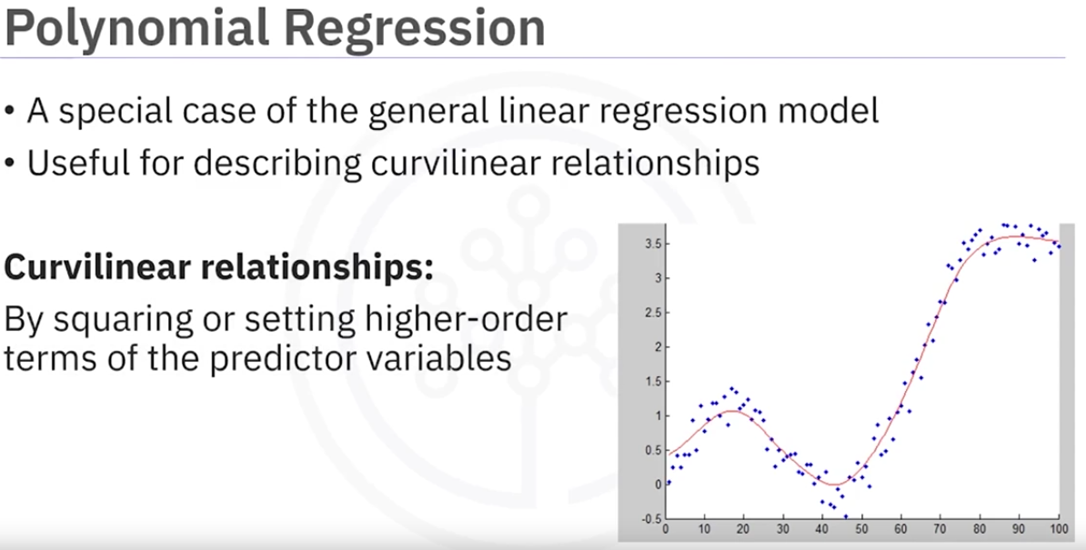

There could be diffenrent orders of polynomial

2nd order - quadratic

3rd order - cubic

Higher order

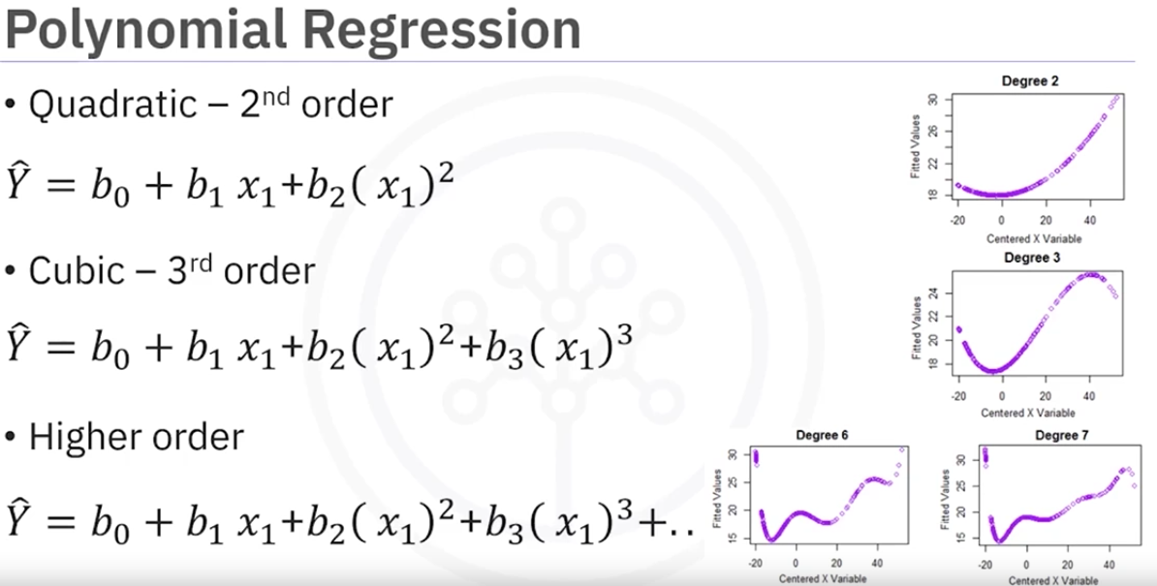

As the degree changes the graph changes.

The bigger the degreethe better fit if you pick the right values.

In all cases the relationship between the parameters is always linear.

Creating a polynomial regression:

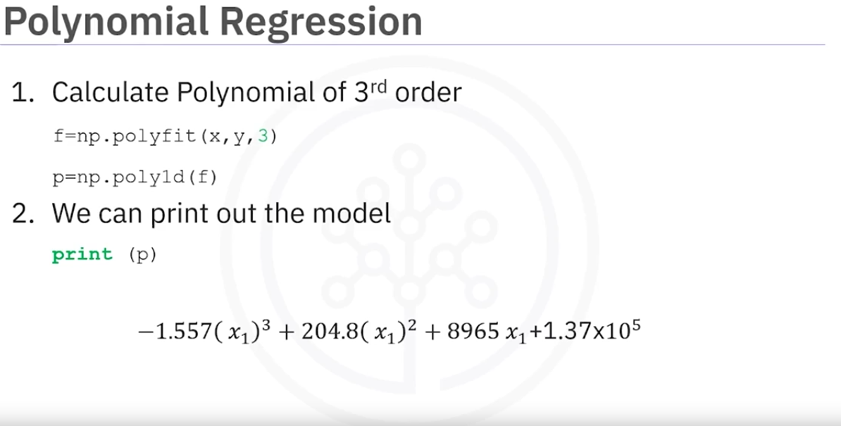

We can also have multi dimensional ploynomial regression. The expression could get complicated,

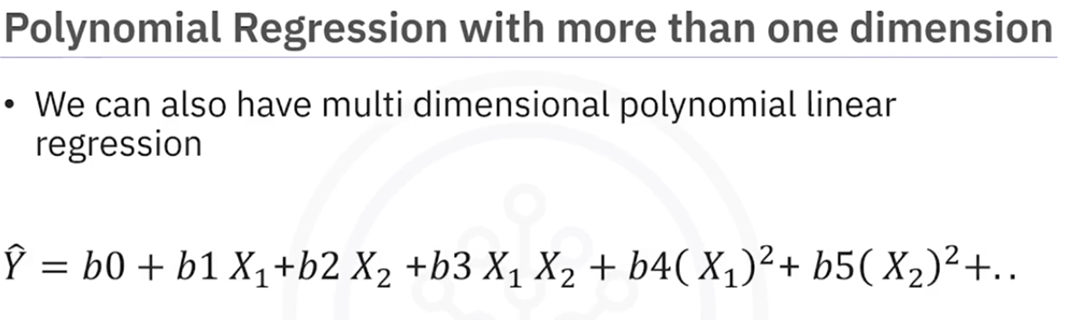

numpy’s polyfit cannot do this kind of regression.

we use preprocessing library in scikit-learn.

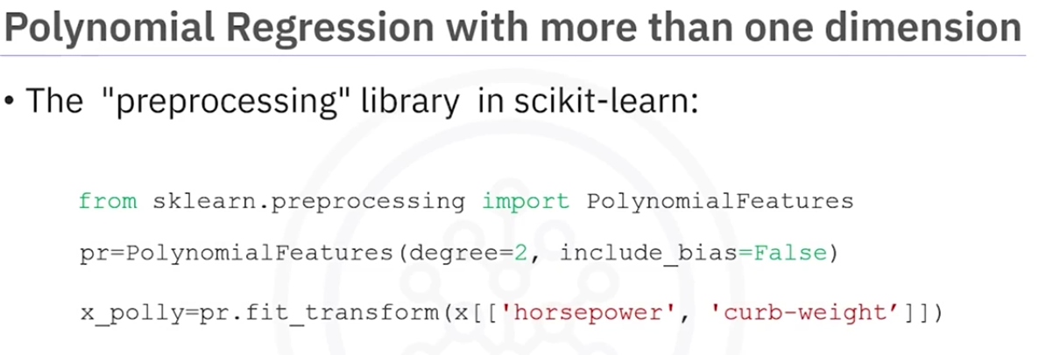

Lets see an intuitive example:

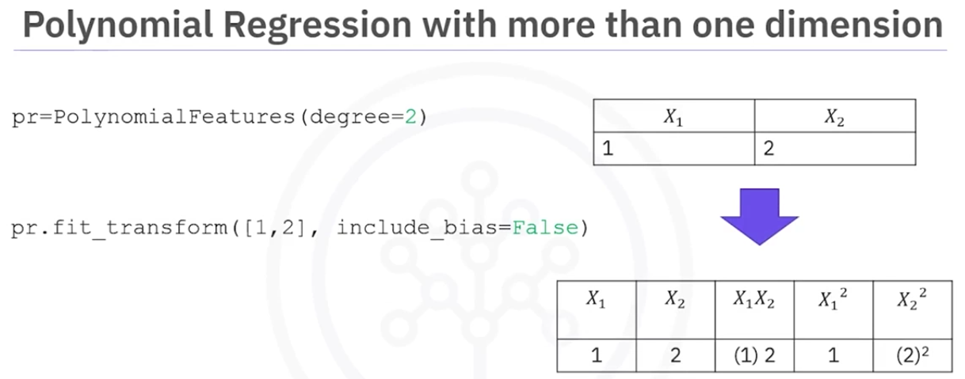

As the data gets larger, we may want to normalize each feature in scikitlearn

Instead we can use the preprocessing module to simplify many tasks.

For example, we can standardize each feature simultaneously,

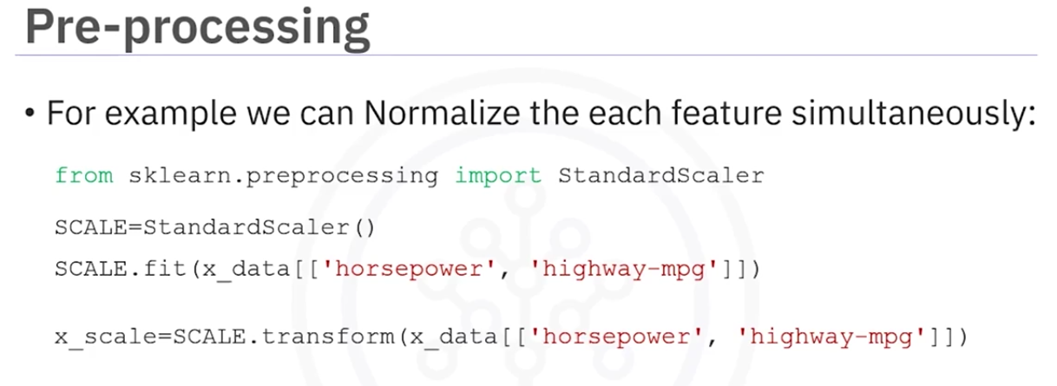

we import StandardScaler then create an object, we then fit the data and then transform it.

There are mode normalization methods available in preprocessing library as wel as other transformations,

Pipelines

we can simplyfy our code by using the pipeline library.

There are many steps in getting the prediction

1. Polynomial tranform
2. Normalization
3. Linear Regression

WE can simplify the process using pipelines

Pipeline sequentially performs a series of transformations.

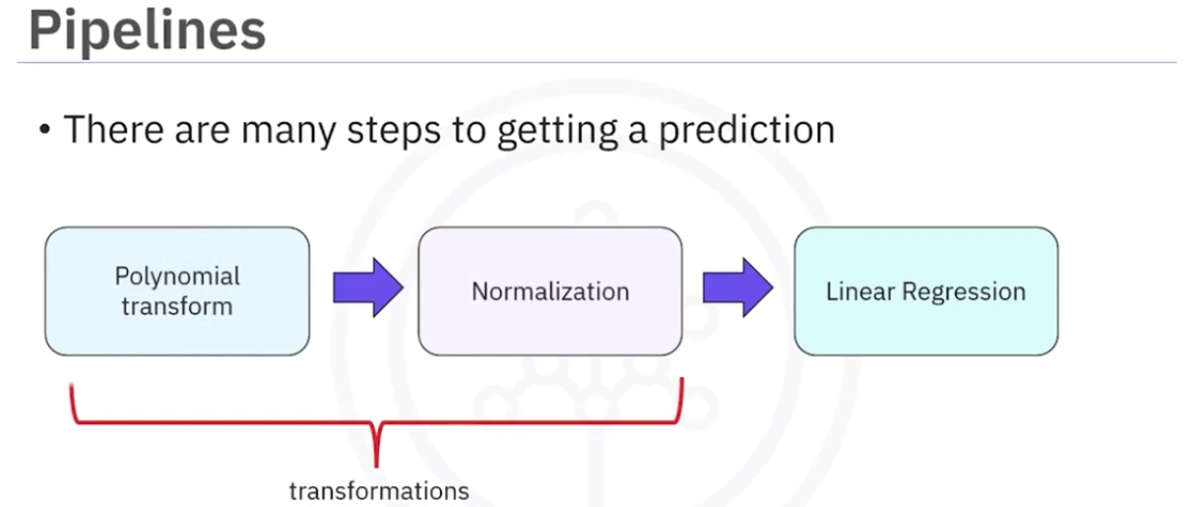

Using a pipeline

First we imort all the libraries

Then we import the pipeline.

Then we create a listof tuples. Each tuple contains the name of the estimator, model as the first value. the second value is the model object.

Then we input the list to the pipeline constructor to create a pipeline object.

Then we can use the fit method to train the model

Then we can use the predict method to find the yhat.

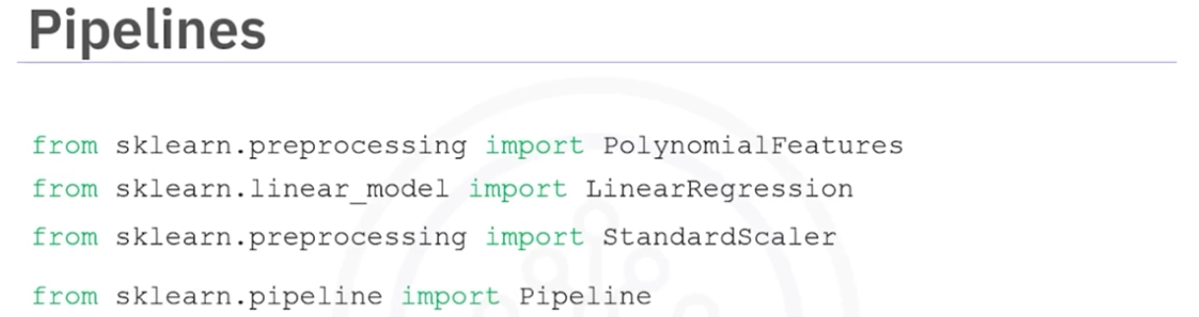

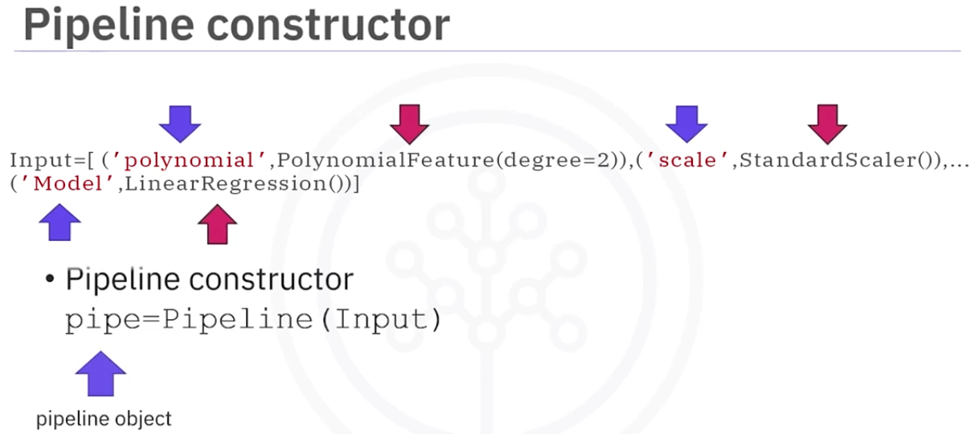

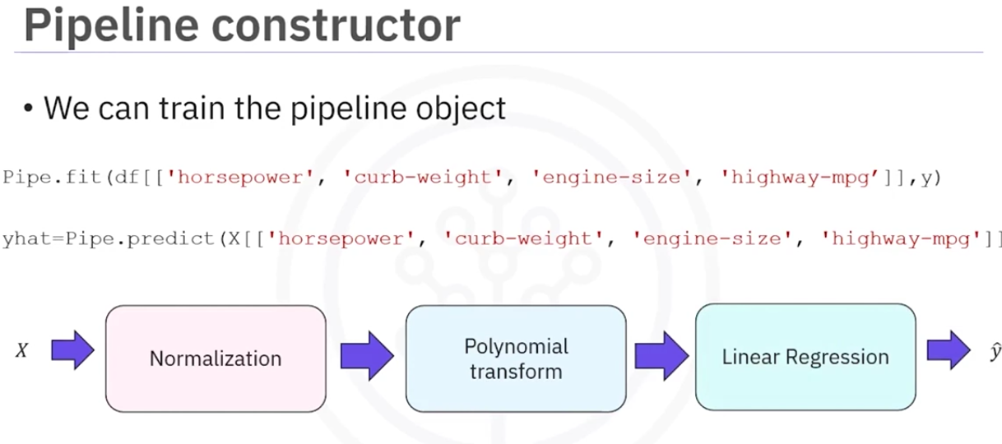

This method will perform polynomial tranform, normalizes the data and then performs the regression.

Measures of In-Sample Evaluation

We already evaluated the the model using visualization.

Now we want to evaluate the model numerically.

There are two important measures that tell us how good our model are.

1. Mean Squared Error(MSE)
2. R-squared(R^2)

MSE:

To measure the MSE, we find the distance between the predicted value(yhat) and actual value(y) and then square it.

We then take a mean or average all the MSE for each data point.

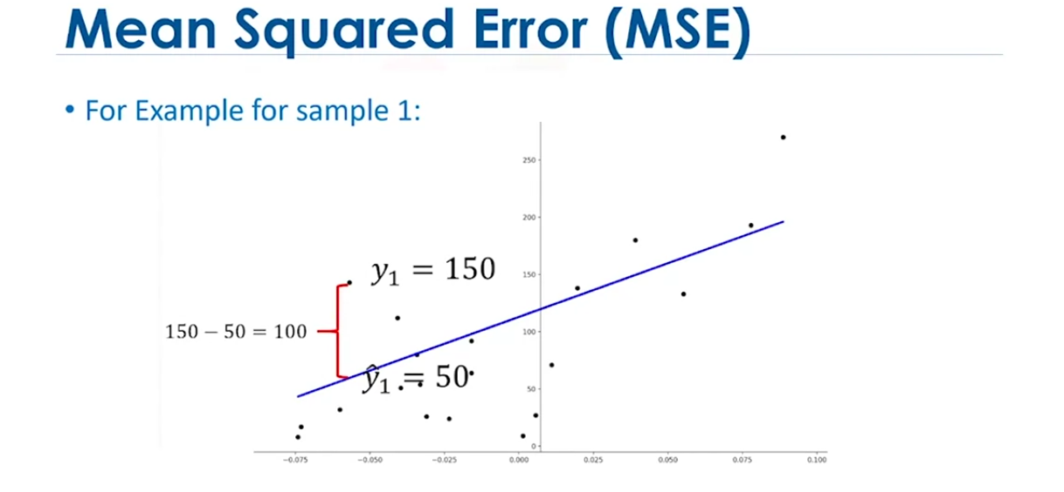

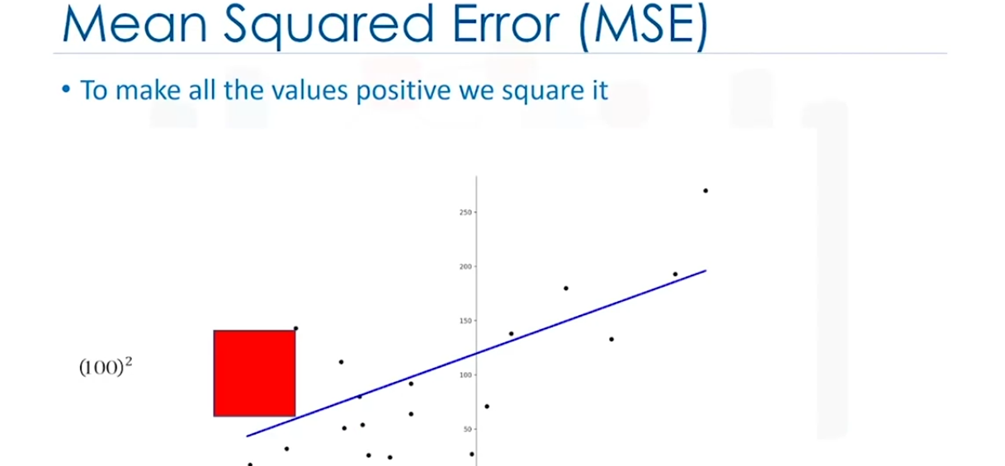



Usage:

WE can import mean_squared_error() from the metrics from sklearn library

The fuction gets two parameters.

1. actual values
2. predicted values

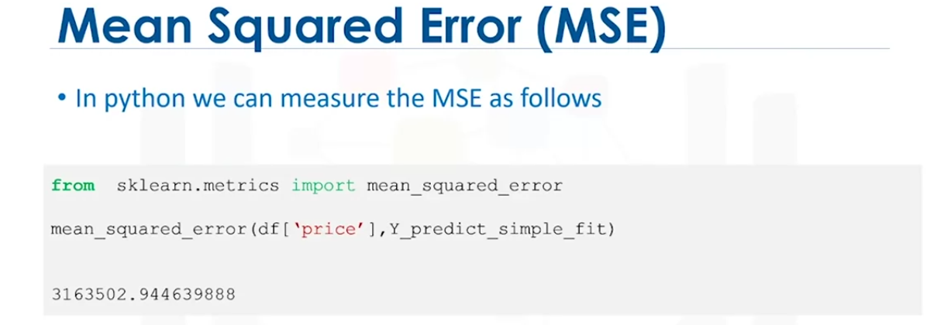

1. Squared:

It is also called as coefficientof determination.

It is a measure to determine how close the data is to the fitted regressio line.

R^2: the percentage of variation of the target variable(Y) that is explained by the linear model.

Think about it as comparing a regression model to a simple model i.e the mean of the data points.

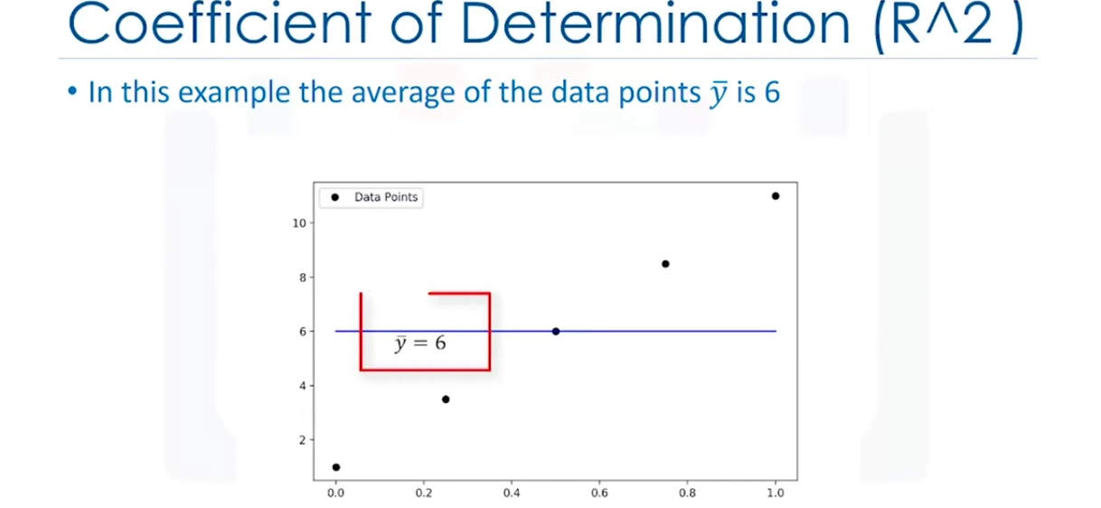

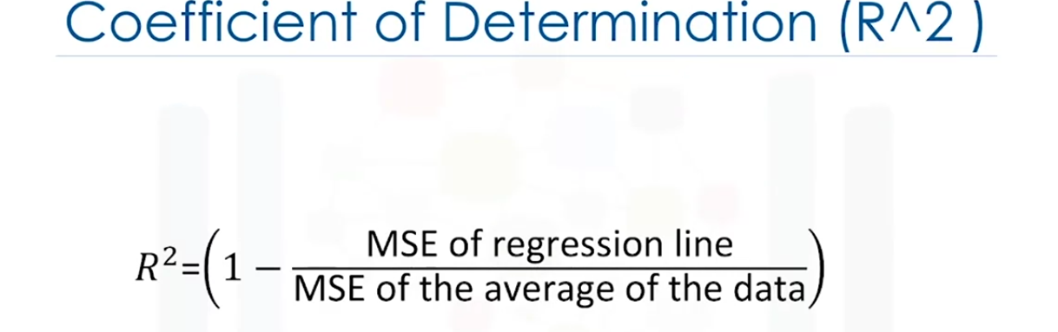

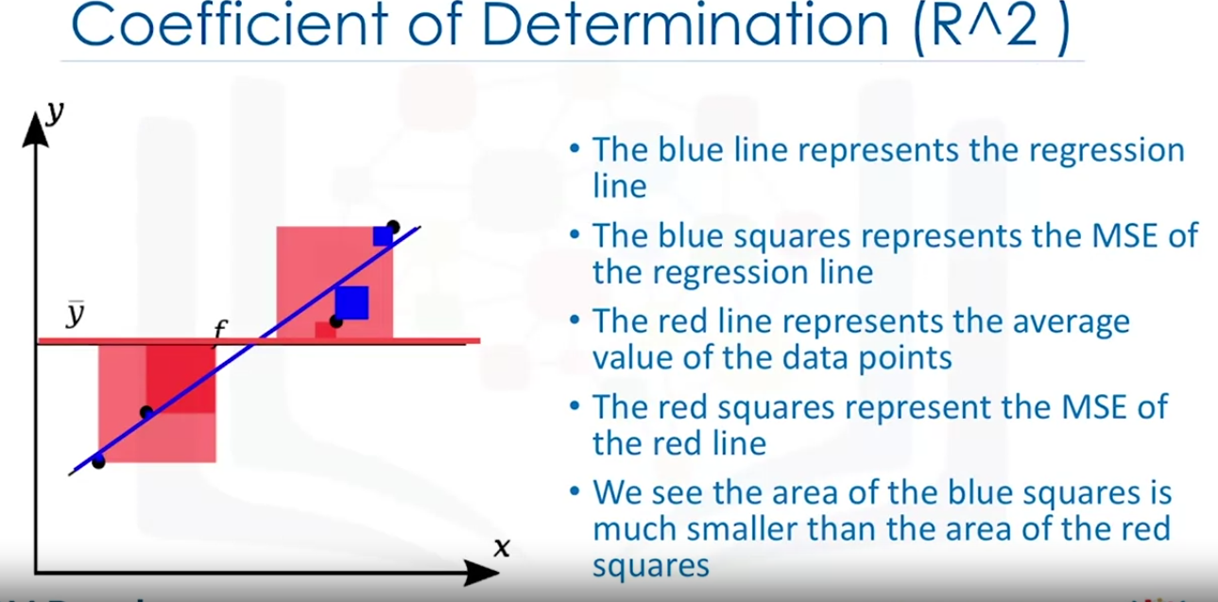

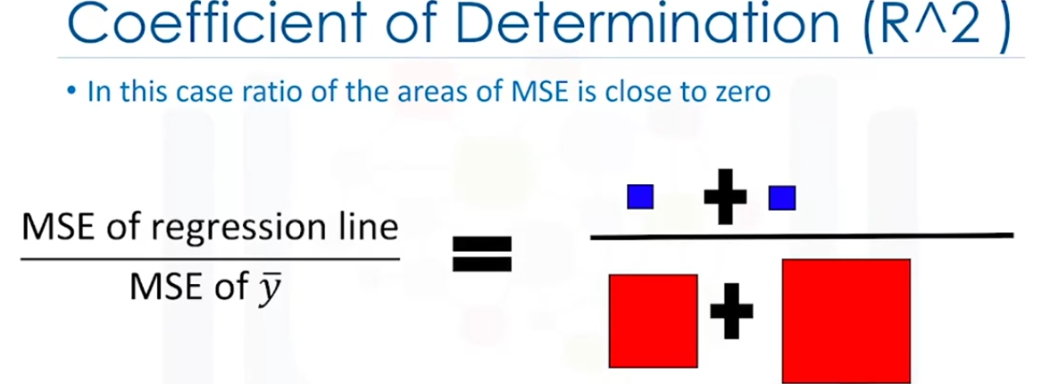

In this case the line is a good fit.

The MSE is small so the numerator is small

The MSE if the average of the data is large as the demoninator is large.

This wil result in something very close to 0.

Pluggung this into the formula of R^2, we get R^2 = 1 which is a good fit,

Here is an example that does not fit the line.

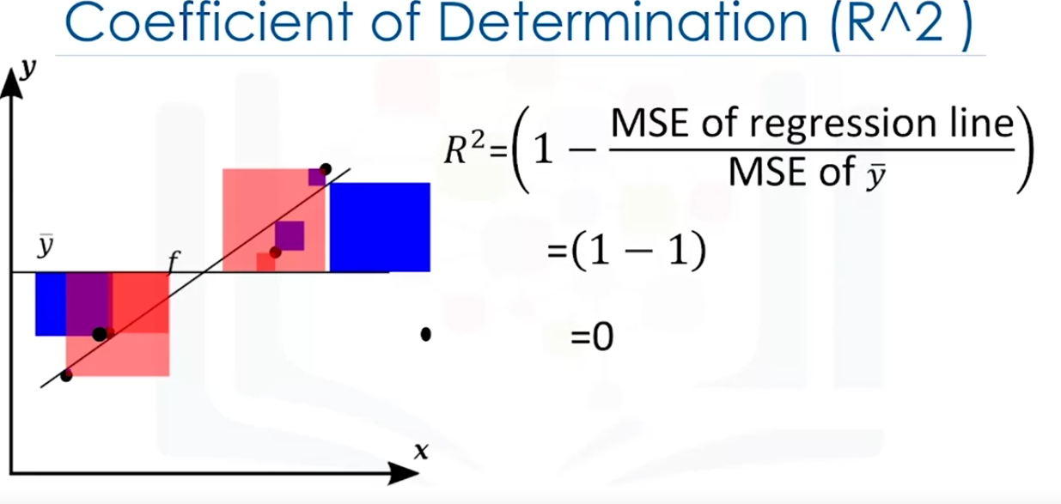

So if R^2 is close to 1 then our model is a good fit. If its close to 0 then its a bad fit

Usage:

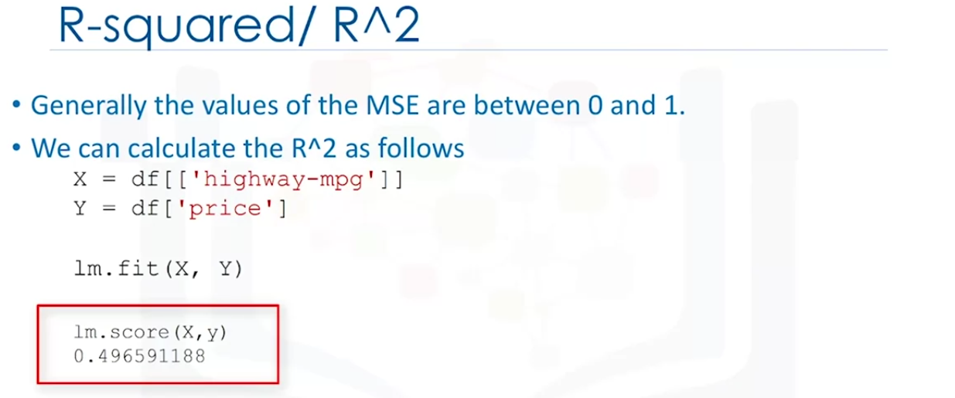

In this example we can approximately say that 49.659 % of the variation of priceis explained by this simple linear model(This means the model is not very accurate).

The r-squared value is generally between 0 and 1. if it is negative it might be because of ocerfitting.

Prediction and Decision Making

How can we determine if a model is correct?

Check if the predicted values make sense

Visualization

Numerical measures for evaluation

Comparing models

Check if the predicted values make sense

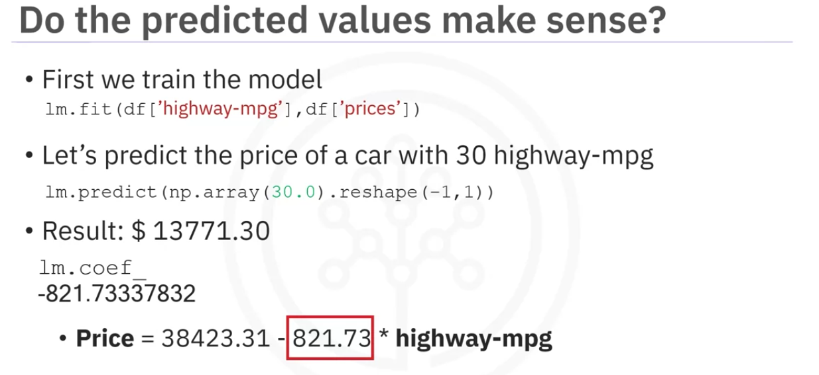

The result is not negative, not extremely low or not extremely high

we can see that coeffiecient is -821.73. This means for 1 unit increase in the highway-mpg, price decreases by 821 dollars. this seems reasonable too.

Sometimes the results produced by the model will not make sennse. if we plot the model out for highway-mpg in the range of 0-100. We will get negative price. This could be because the value in that range is not realistic or the linear assumption is incorrect or we dont have data for cars in that range. In this case it is unlikely that a car will have a fuel milage in that range. So our model seems valid.

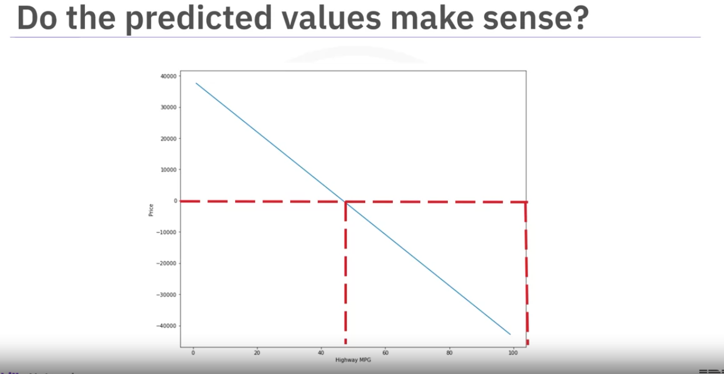

Usage:



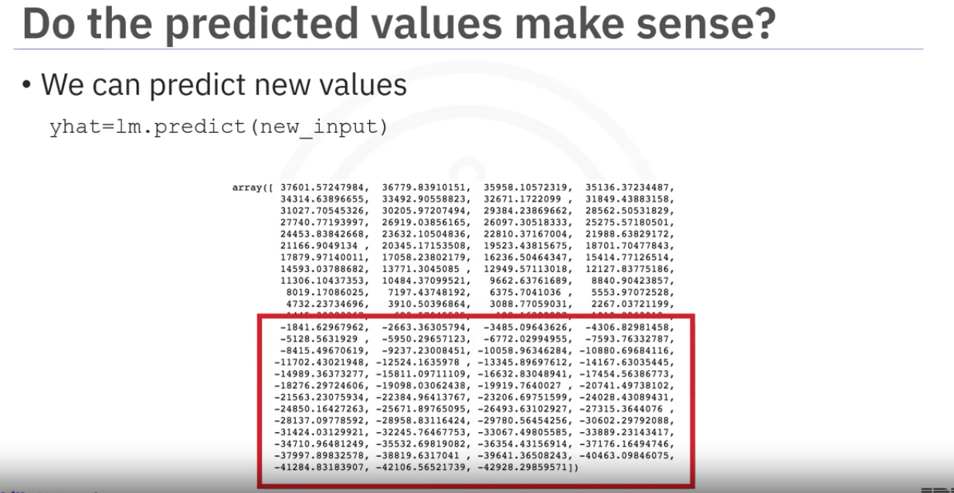

We can see here many values are negative when we predict.

Visualization

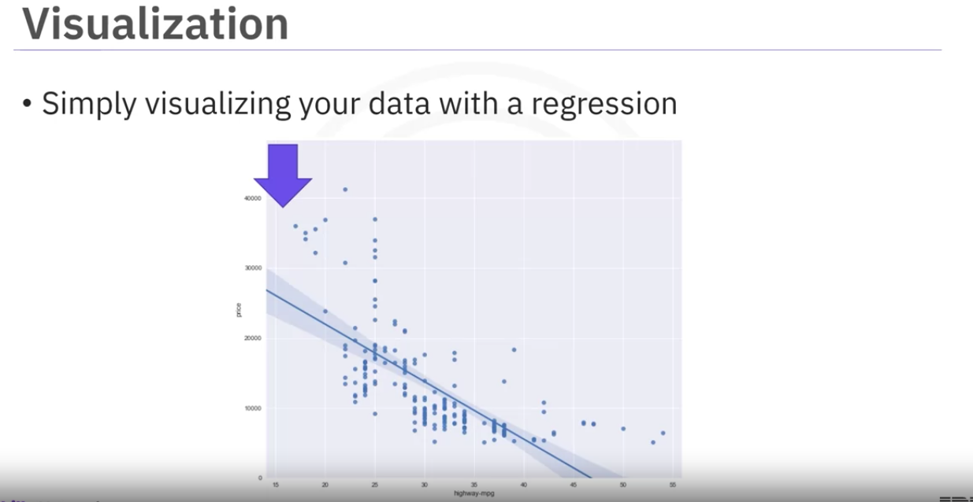

Regplot isone of the first things we need to do.

The plot shows clear negative relationship .

The plot also shows non-linear behaviour.

Examining the residual plot shows a curviture.

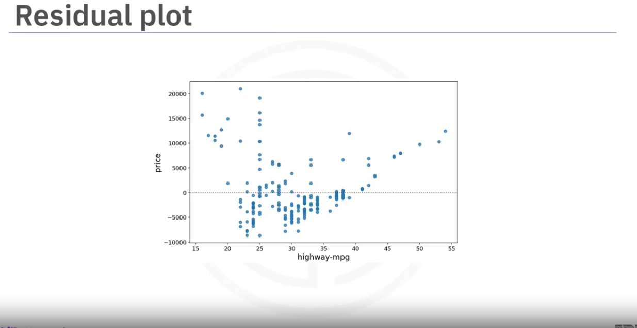

Plotting a distribution plot is a good method for multiple linear regression.

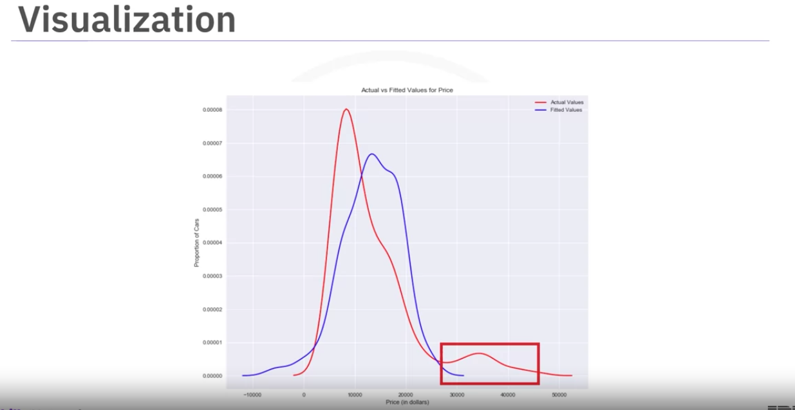

MSE:

MSE is the most intuitive way to measure if the model is good or not.

The following diagram show a MSE of 495

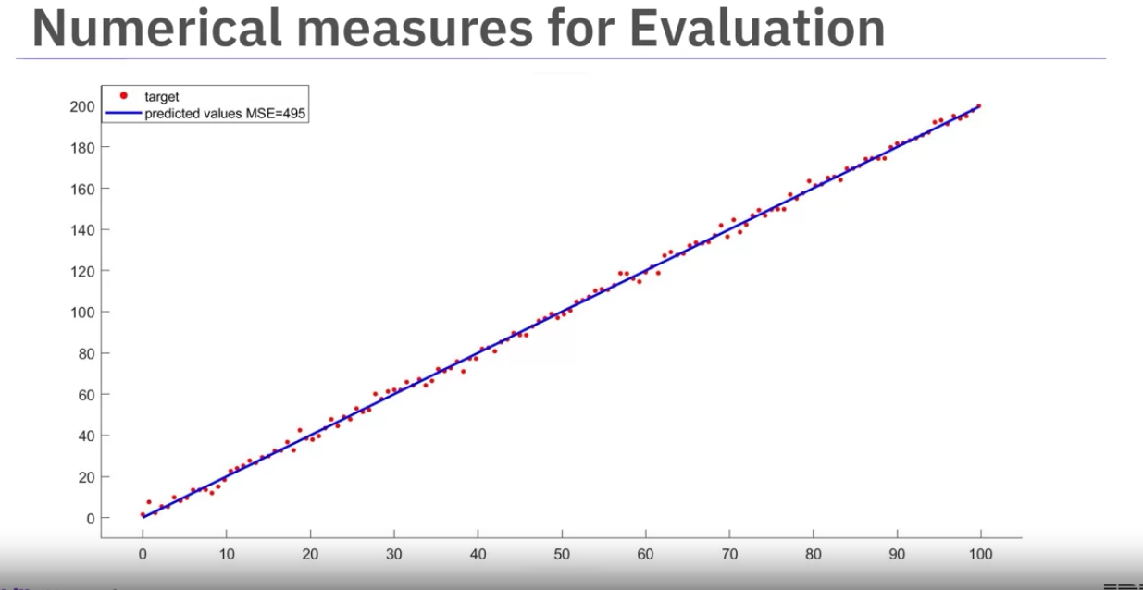

The following error shows the MSE of 3562

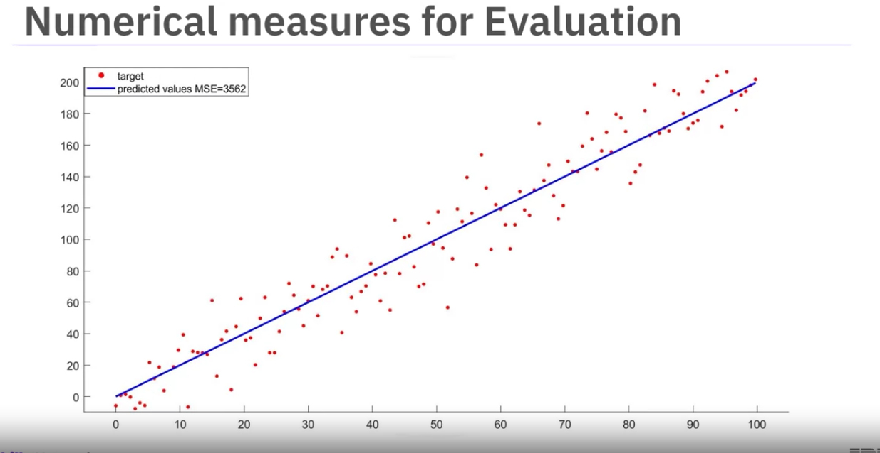

The following diagram show an MSE of 12870

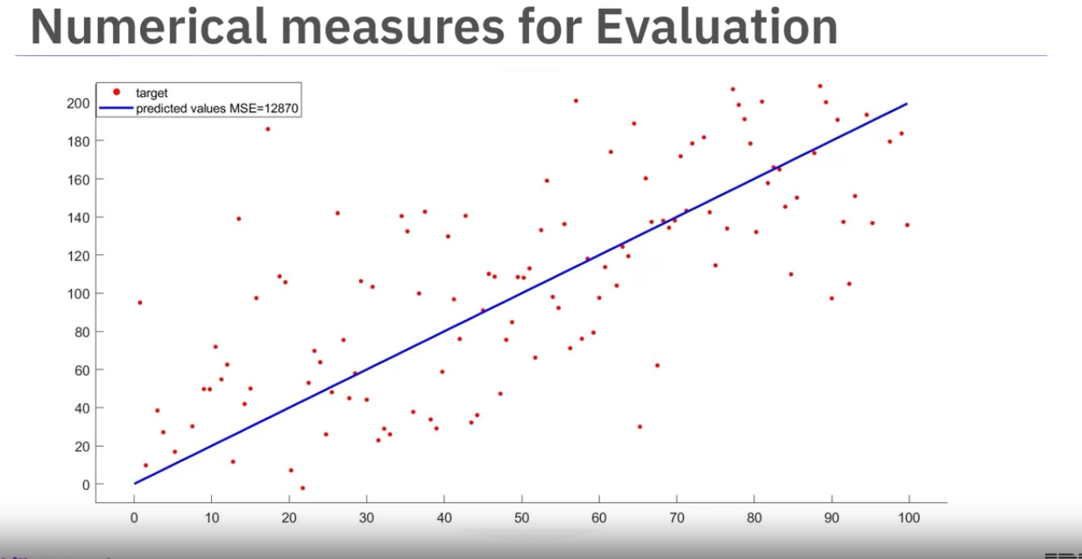

As the MSE increases the targets move away from the predictions.

R-Squared

Another popular error

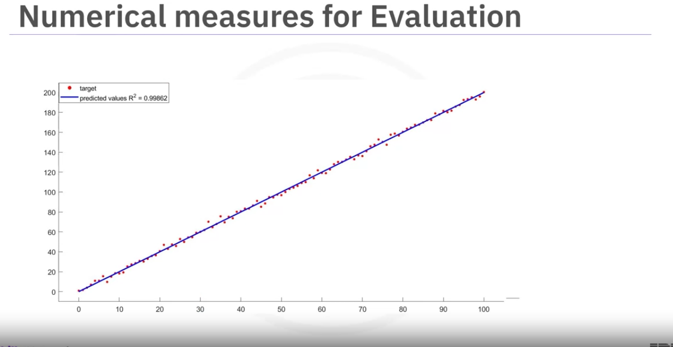

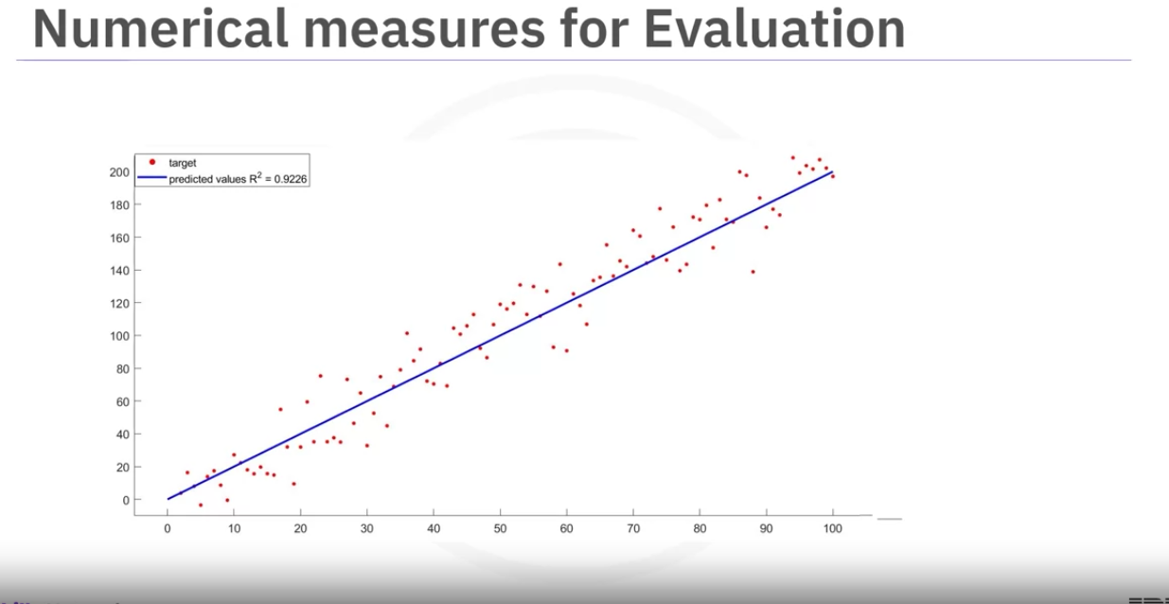

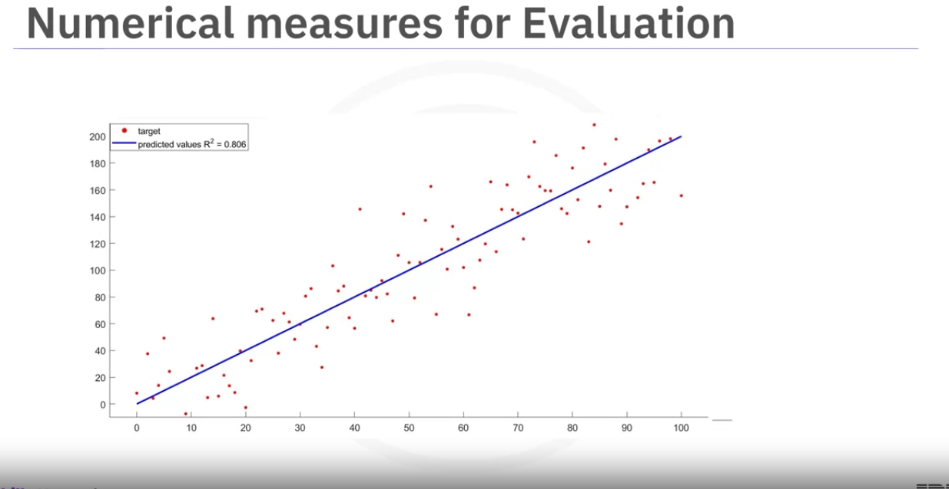

As r-squared of reducing make the actual values move away from the predicted line. But still in all three cases the linear relationship is clearly evident. Drawing the variance lines for the last ine shows that its parallel to the predicted line.

A good r-squared value depends on what we are studying.

Falk and Miller (1992) (authors) say that the r-squared should be greater than or equal to 0.10.

Comparing MLR and SLR

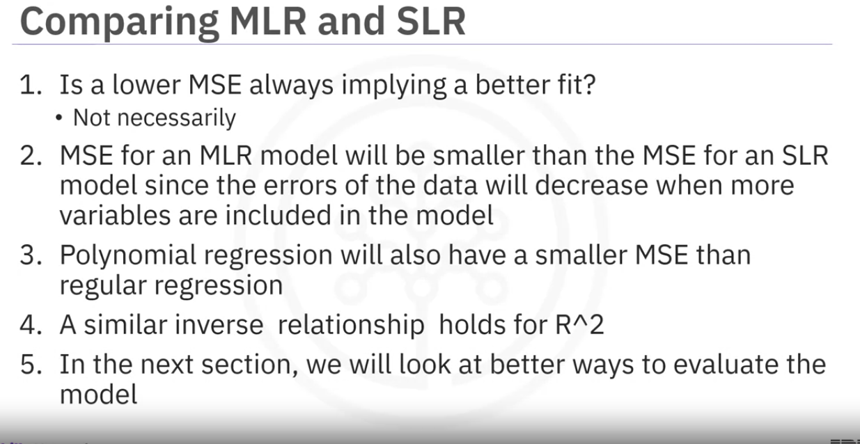

Summary:

Congratulations! You have completed this lesson. At this point in the course, you know:

Linear regression refers to using one independent variable to make a prediction.

You can use multiple linear regression to explain the relationship between one continuous target y variable and two or more predictor x variables.

Simple linear regression, or SLR, is a method used to understand the relationship between two variables, the predictor independent variable x and the target dependent variable y.

Use the **regplot** and **residplot** functions in the Seaborn library to create regression and residual plots, which help you identify the strength, direction, and linearity of the relationship between your independent and dependent variables.

When using residual plots for model evaluation, residuals should ideally have zero mean, appear evenly distributed around the x-axis, and have consistent variance. If these conditions are not met, consider adjusting your model.

Use distribution plots for models with multiple features: Learn to construct distribution plots to compare predicted and actual values, particularly when your model includes more than one independent variable. Know that this can offer deeper insights into the accuracy of your model across different ranges of values.

The order of the polynomials affects the fit of the model to your data. Apply Python's **polyfit** function to develop polynomial regression models that suit your specific dataset.

To prepare your data for more accurate modeling, use feature transformation techniques, particularly using the **preprocessing** library in scikit-learn, transform your data using polynomial features, and use the modules like **StandardScaler** to normalize the data.

Pipelines allow you to simplify how you perform transformations and predictions sequentially, and you can use pipelines in scikit-learn to streamline your modeling process.

You can construct and train a pipeline to automate tasks such as normalization, polynomial transformation, and making predictions.

To determine the fit of your model, you can perform sample evaluations by using the Mean Square Error (MSE), using Python’s **mean_squared_error** function from scikit-learn, and using the score method to obtain the R-squared value.

A model with a high R-squared value close to 1 and a low MSE is generally a good fit, whereas a model with a low R-squared and a high MSE may not be useful.

Be alert to situations where your R-squared value might be negative, which can indicate overfitting.

When evaluating models, use visualization and numerical measures and compare different models.

The mean square error is perhaps the most intuitive numerical measure for determining whether a model is good.

A distribution plot is a suitable method for multiple linear regression.

An acceptable r-squared value depends on what you are studying and your use case.

To evaluate your model’s fit, apply visualization, methods like regression and residual plots, and numerical measures such as the model's coefficients for sensibility:

Use Mean Square Error (MSE) to measure the average of the squares of the errors between actual and predicted values and examine R-squared to understand the proportion of the variance in the dependent variable that is predictable from the independent variables.

When analyzing residual plots, residuals should be randomly distributed around zero for a good model. In contrast, a residual plot curve or inaccuracies in certain ranges suggest non-linear behavior or the need for more data.